SETTING UP THE FLIGHT DECK

- Set the Flight Deck TOUR on the green about 3-10 feet from the target you intend to use.
Place one tee into the rear tee hole and secure to green.

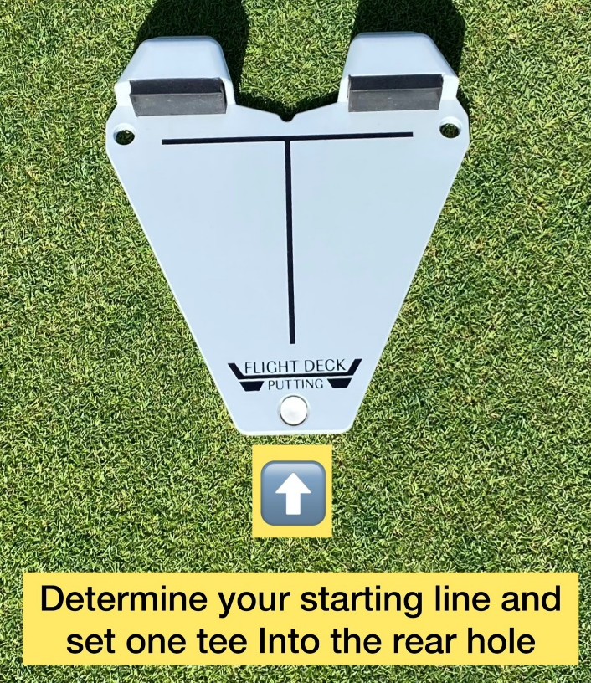

- Pivot the Deck to the correct target line.

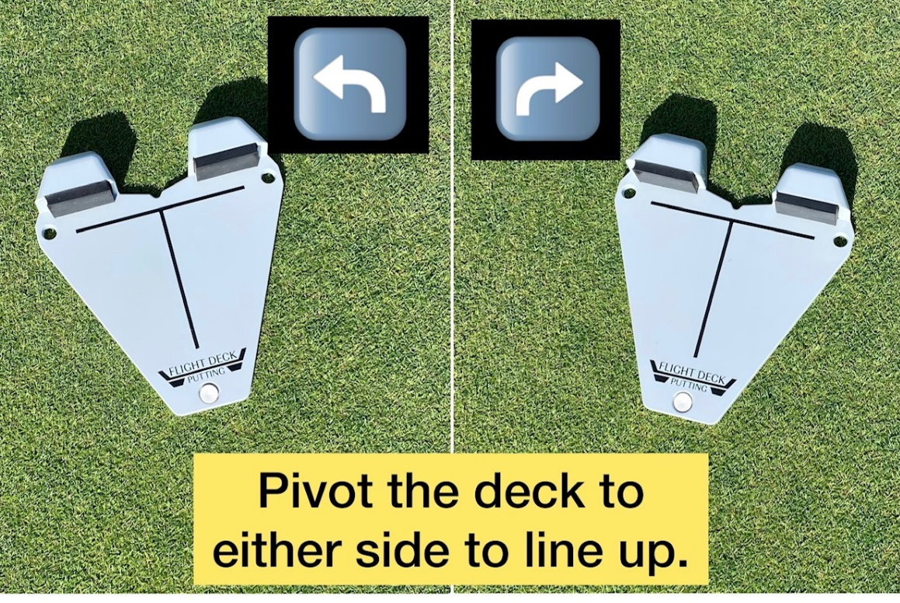

- Next, add 2 tees to the two front holes to secure the Deck. Press the tees down into the green, so they are flush and firm.

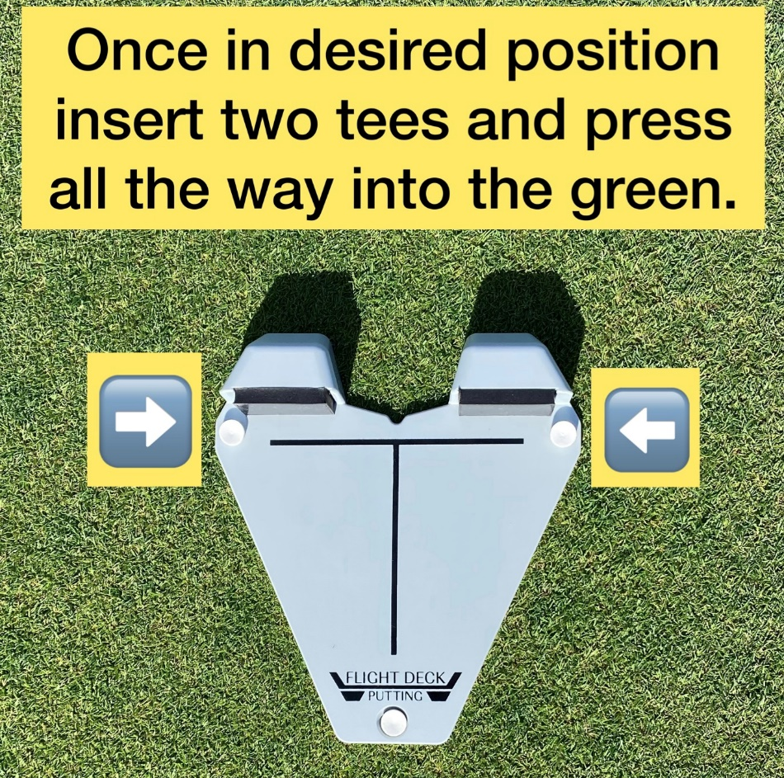

BASIC TRAINING WITH FLIGHT DECK

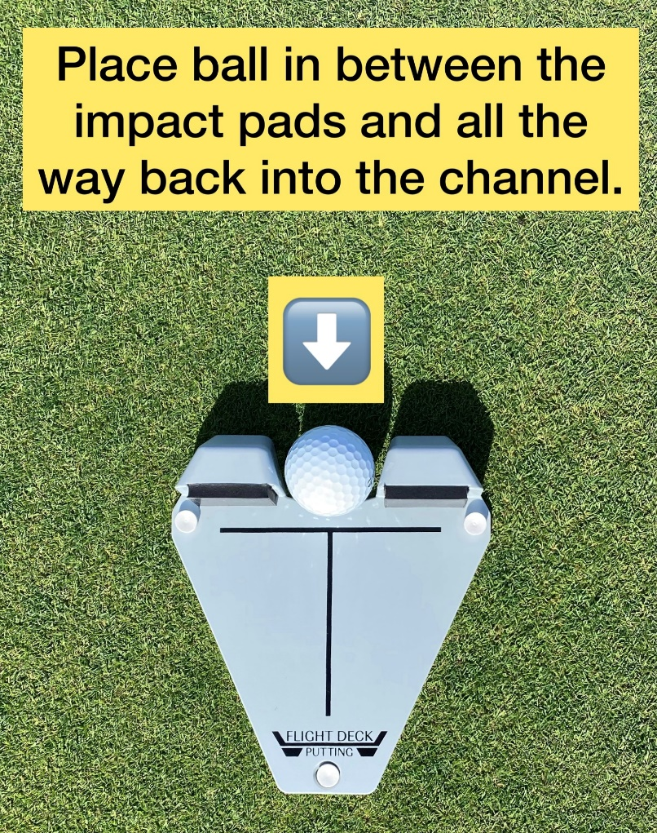

- Set the ball to the farthest rear position notch between the two impact pads.

- Begin to train by striking putts normally.

- Hold your finish flat against the impact pads for 3 seconds. This helps to ingrain the feel of a solid and square impact position.

- Check to see if the center mark of your putter matches up with the centerline of the deck.

Note: With each practice stroke – (with or without a ball) -- the goal is impact feedback of a square putter face angle is enhanced and ingrained.

IMPACT FEEDBACK

- With each rep, impact feedback is received from the impact pads and ball contact.
- A square putter face at impact will feel solid and firm with less vibration and recoil.
- A putter face angle that is not square at impact will cause you to feel more vibration and recoil.

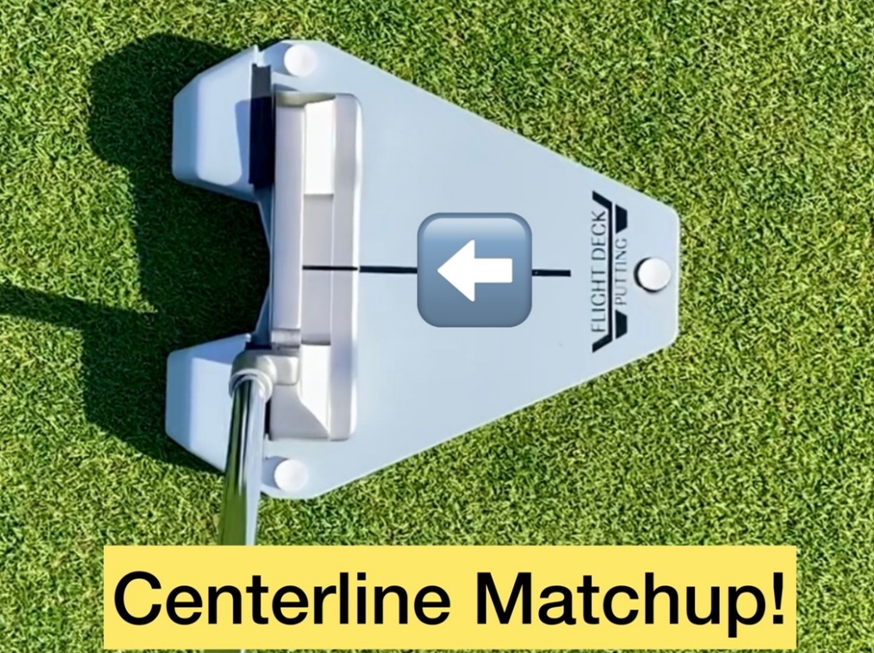

- If your putter returns offline (unsolid strike) or you strike the heel or toe impact pad first (not square), the putter may shift to one side or the other and you will notice the centerline “matchup” did not occur. The putter center (sweet spot) should match up to the centerline of the deck while you are holding your finish against the pads. Always check for this and always hold the finish position!

See Square, Feel Square and Repeat Square!

Advanced Training with Flight Deck

- Make practice strokes on the Tour deck without a ball.

- Try to strike the impact pads simultaneously and hold the finish.

- Check to see if the center mark of your putter matches up with the centerline of the deck.

- Close your eyes and repeat (#1),

- Next, open your eyes to see if the center mark of your putter matches up with the centerline of the deck.

- Next, add a ball, keep your eyes closed and make a stroke holding your finish. Again, check for the centerline matchup.

- Alternate one-handed training, doing your best to hold the finish against the impact pads. Check again for a centerline matchup.

- One-handed training with your eyes closed is the ultimate test! Always check for a centerline matchup after each stroke.

- After warming up at a short range from 3 to 10 feet for solid and square impact training, set up for mid-range 12 - 30 ft length putts for distance control training.

- Set up markers at different mid-range length intervals and work to find the proper backswing lengths needed to roll the ball at different distances.

- Alternate putts from both on and off the deck for 5 to 10 reps each way.

Pre-round warmup with Flight Deck

- Set the deck for a straight-in putt at a desired short-range distance.

- Position the putter face against the pads without a ball for several seconds and run your eyes to the target and back several times to confirm the proper perspective of a square putter setup position. (This reaffirms what square putter alignment looks and feels like.)

- Next, strike a few putts as usual and hold your finish flat against the impact pads for at least 3 seconds. This reaffirms the feeling of solid and square impact.

- Alternate striking the ball from both on and off the deck for 5 to 10 repetitions each way. This is an excellent way to repeat the sight and feeling of a solid and square impact to prepare for your round. For off-deck practice, take your putting setup and begin hitting putts; if the ball goes left, your putter face is closed; if it goes right, your putter face is open. Go back to the Flight Deck and start practicing seeing, feeling, and repeating a square putter face at impact.

Post-round with Flight Deck

- Repeat the same pre-round warmup and add some advanced training drills as listed.

Drills for KIT

- Impact training: Using the Flight Deck TOUR, hit putts holding your finish against the impact pads for maximum feedback.
2) eye alignment plus impact train: Use the DUO mirror on the deck while working on putting impact training.

3) Eye alignment: Use the DUO mirror to check your setup alignment and eye position. If desired, add tees for putter gate training.

4) Start Line: Use the DUO’s flip side to train the ball’s starting line. You may add tees for your desired putter and ball gate width.

